**School Management System**

**Submitted By**

Team: Resolver

Name: Ashim Khadka

Email: ashim.jung.khadka@gmail.com

Table of Contents

**Introduction2**

Project Introduction2

Problem Statement2

Objective2

Scope and Limitation2

**Methodology3**

Data Collection3

SDLC Approach3

Feasibility Analysis3

Requirement Analysis and Design3

Implementation4

Testing Methods4

Maintenance4

**System Development Tools5**

Resource Requirement5

Front End Tools5

Back End Tools5

**Project Output6**

**Conclusion9**

Introduction

* 1. Project Introduction: “School Management System”

School is the place where student used to go for education. But school needs to manage different things to provide better education and this is usually falls under the school management. School management consists of different departments like account, library, sports, lab etc. These different departments have different protocols and need to keep records of each and every student individually. This is where our software comes and help them to provide better education.

* 1. Problem Statement

These problem arises, when every department has to keep their records individually:

1. Data duplication
2. Indexing should be maintain
3. Data integrity
4. Large number of files and storage
5. Accessible by unauthorized person
6. Generating reports will be handy
   1. Objective

Solutions to the above problem are the main feature of our application, which are listed here:

1. Since, every record are kept in same place, data duplication will be omitted.
2. Indexing is maintained by using unique key, every record can be kept in same place.
3. Information about student, teacher are placed in a systematic way, such that data integrity will be achieved without any problem.
4. Since our application omits the data duplication, small space for files will be sufficient.
5. We can assign privilege in our application, which blocks unauthorized person from accessing it.
6. Generating reports is best part of our application, can be provided just by a single click.
   1. Scope and Limitation

Being a web-based application, the proposed project will not have any geographical bounds. Since, confidential data are stored, will be accessible by only locally not globally. Although you have generosity for this project, not all the problem which arises at school management can be solved like library management, payroll management within limited period of time.

Methodology

1. Data Collection:

This project is the real time project. Several online and offline documents were studied to enhance the functionalities of this project. Some of the testing data are randomly inserted and some of them are inherited directly from online which are listed here.

* http://en.wikipedia.org/wiki/School
* http://bnks.edu.np/about/school-management/

1. Software Development Life Cycle Approach: “WATER FALL”
   1. **Feasibility Analysis**

SMS Software is for the school management where different activities can be done in same place in a systematic way. Since, this project is not bounded by the geographical area or related to any other vendor, it will be more comfortable to enhance, as well as feasible to any environment.

* 1. **Requirement Analysis and Design**

Every school management is headed towards its goal. To meet its goal, different operations and decisions are to be taken by different participants. We make sure that they achieve their goals within given period of time. And we help them by providing different feature which are listed here:

1. **Login Page**

This is first page which will be seen by any user. This page asks for user name and password to verify whether the user is authenticate or not. Every user who tries to login are validated and verified and this help to make sure that they get the authorized access.

1. **User Management**

Under this title, every user can view and modify their information. High privileged user can assign privilege to others based on their job position and their assignments.

1. **Student Management**

Here every student details are listed as well as can be modified. Student records are categorized based on their grade and section. They can also view their subject to read throughout the year.

* 1. **Implementation**

Since, this is web-based application, different technologies are used to achieve the goal, which is listed here:

1. **HTML**

It is used for the graphical user interface.

1. **CSS**

It is used to make web page well organized and formatted.

1. **Bootstrap**

It is used to enhance the functionality of HTML/CSS.

1. **JQuery**

It is used to make validation in client side.

1. **Java**

It is used to make the bridge between user-interface and database layer.

1. **PostgreSQL**

It is used to store information.

* 1. **Testing Methods**

To check whether the developed project is ready to go for live or not, various kinds of testing methods are used, which are listed here:

1. Integration Testing

To ensure that interfaces between module works.

1. Volume Testing

To ensure that system works with the expected volume of data.

1. Acceptance Testing

To ensure that system does what the user want.

* 1. **Maintenance**

Every developed application will definitely undergo changes. We will make sure that every part of changes or maintenance will be done within a shortest period of time. Any changes will be updated manually.

System Developing Tools

1. Resource Requirement
2. **Hardware (For Project Development)**

Processor: Intel Pentium 4 or Higher

Memory: 512 MB or More

Storage: Hard Drive with at least 5 GB free

1. **Software (For Project Development)**

Operating System: Windows or Linux

Development Tools: Eclipse Juno or Higher

pgAdmin III(GUI for PostgreSQL)

Web Browsers: Internet or Mozilla Firefox or Chrome (preferred) at least one

Server Package: PostgreSQL

Technology: HTML, CSS, JQuery, Bootstrap, Node.js

Language: Java

Framework: Spring, Hibernate

Tool: Maven

1. **Project Deployment Requirement**

Web Server: Tomcat Server

Database Server: PostgreSQL Server

Others: pgAdmin III(GUI for PostgreSQL)

1. Front End Tools

Development Kit: Eclipse

Web Browsers: Internet or Mozilla Firefox or Chrome (preferred) at least one

Technology: HTML, CSS, JQuery, Bootstrap, Node.js

Language: Java

Framework: Spring, Hibernate

Tool: Maven

1. Back End Tools

Database Server: PostgreSQL Server

Web Server: Tomcat Server

Project Output

**Login Page Log Off Page**

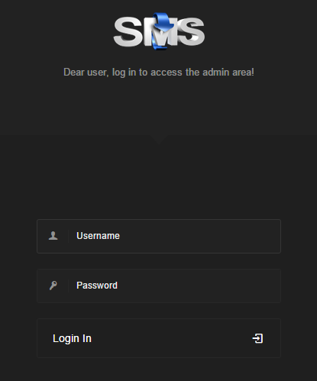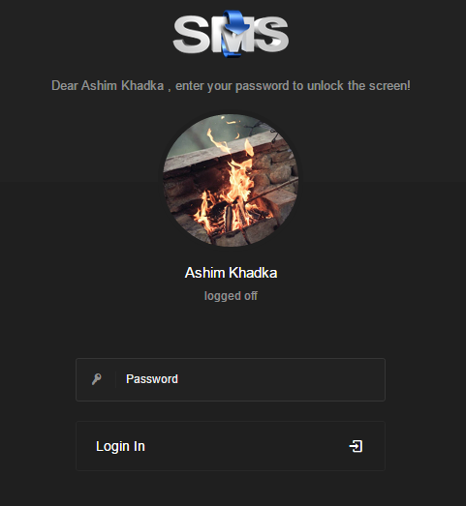

**Grid Page**

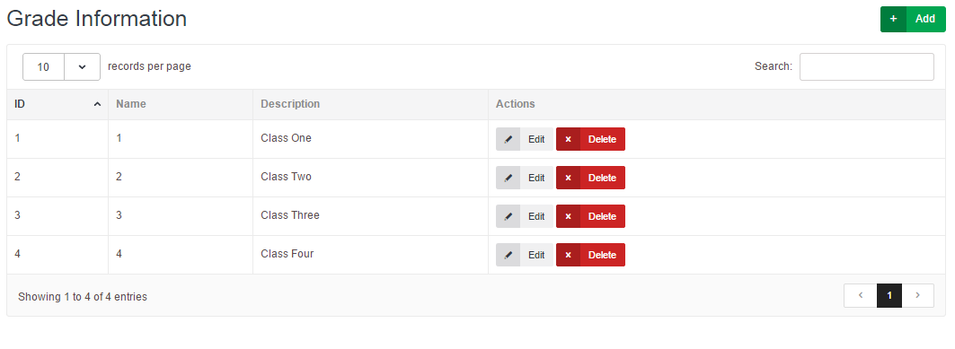

**Form Page**

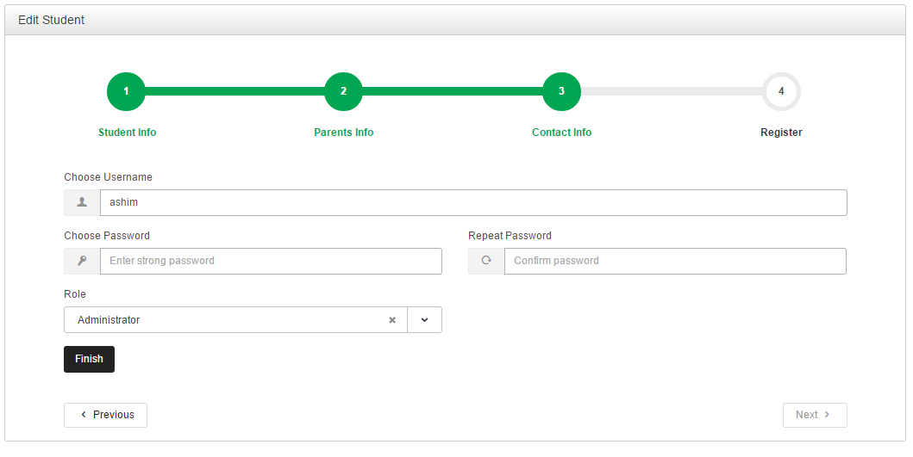

**Privilege Page**

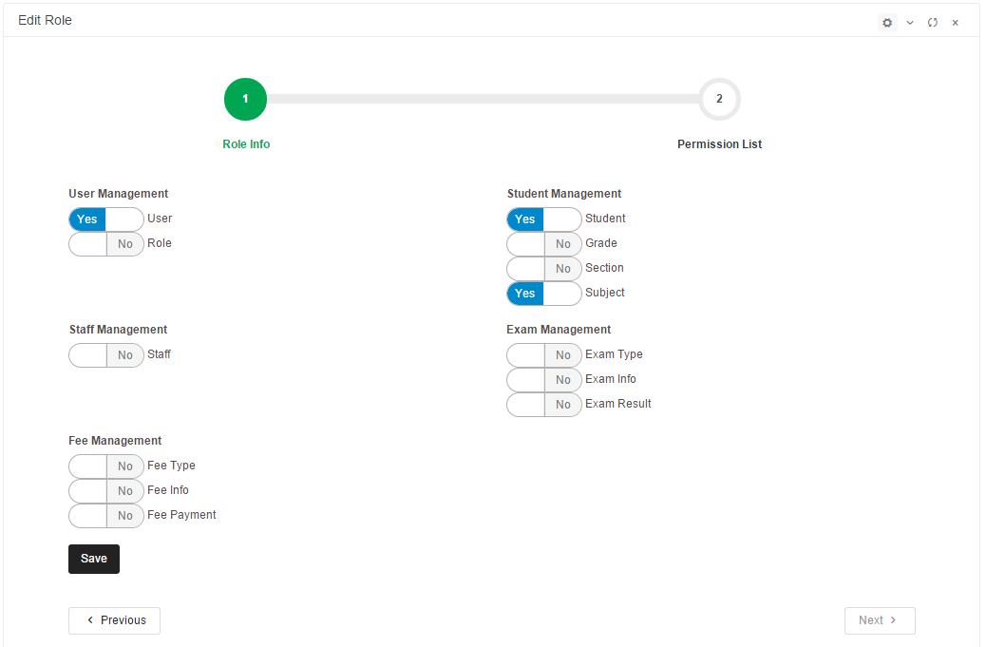

**Menu List**

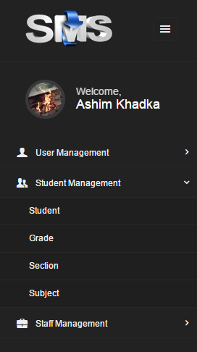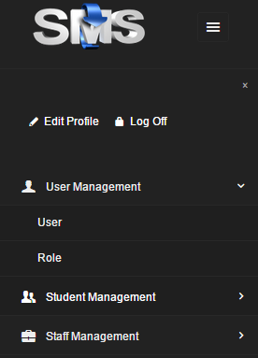

Conclusion

The proposed school management system is based on well-known fact and based upon web-based application. This project is developed using open source programming language, different tools for it will be available via internet and can be enhanced further in future depending upon the requirement. This project is evaluated in every aspect using Software Development Life Cycle.